Lab – Extra : Hoang Duy Vu - 986170

[cloudera@quickstart ~]$ hadoop jar /home/cloudera/Desktop/averagetemp.jar AverageTempStation /user/cloudera/input/NCDC-Weather_small.txt /user/cloudera/output

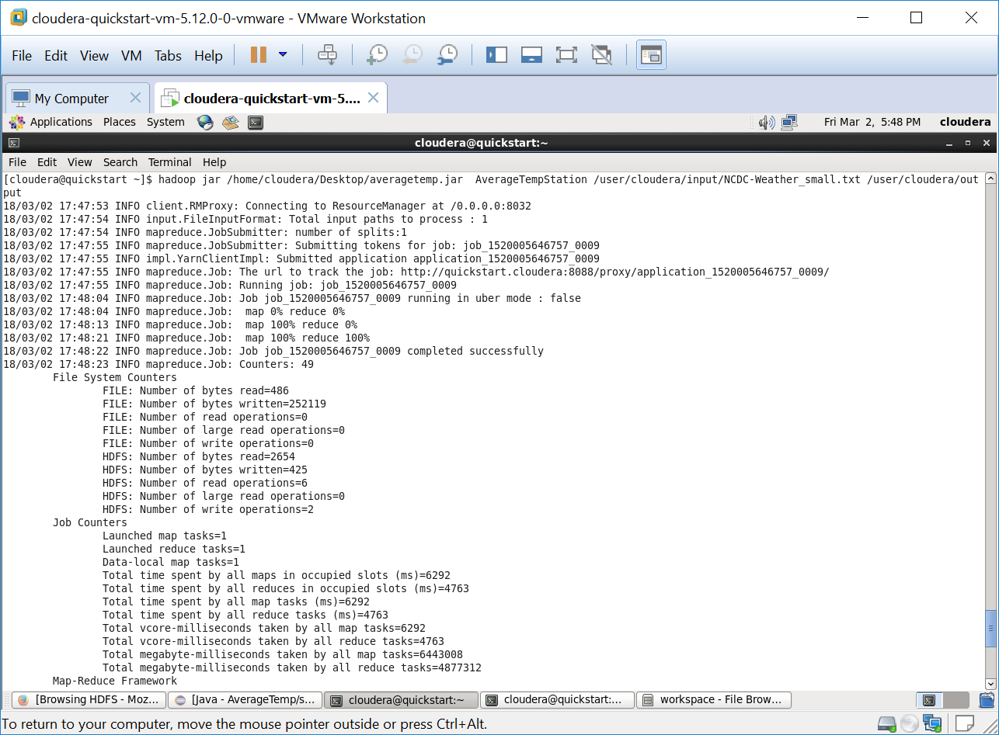

[cloudera@quickstart Desktop]$ hadoop fs -cat output/StationTempRecord-r-00000

